Big Data Visualization Assignment – 1

Participants –

Vijay Kumar (RA2111027010001)

Harshit Kumar (RA2111027010003)

Gaurang Ashava (RA2111027010007)

Section – AA1

Department - DSBS

Dataset – mobiledataset.csv

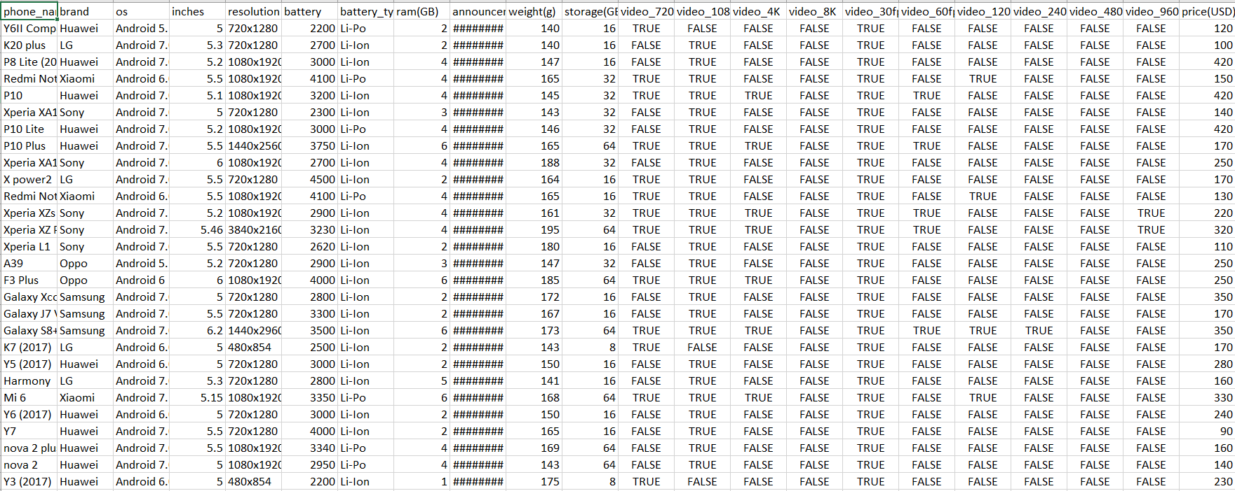

Q)  Define and Explain your Dataset fields.

phone_name: This field typically contains the name or model of the smartphone. It represents the specific identifier or name associated with each smartphone in the dataset.

brand: This field represents the brand or manufacturer of the smartphone. It identifies the company that produced the phone.

os: This field indicates the operating system that the smartphone uses, such as Android, iOS, or any other mobile operating system.

inches: This field represents the screen size of the smartphone, typically measured in inches diagonally. It specifies the physical size of the phone's display.

resolution: This field describes the screen resolution of the smartphone's display, typically given in pixels (width x height). For example, "1080x1920" represents a Full HD resolution of 1920 pixels in width and 1080 pixels in height.

battery: This field denotes the battery capacity of the smartphone, often measured in milliampere-hours (mAh). It indicates the amount of electric charge the battery can hold.

battery_type: This field specifies the type of battery used in the smartphone. Common battery types include Li-Po (Lithium Polymer) and Li-Ion (Lithium-Ion).

ram (GB): This field represents the amount of RAM (Random Access Memory) in the smartphone, typically measured in gigabytes (GB). RAM is used for temporary data storage and running applications.

announcement_date: This field indicates the date when the smartphone was officially announced or introduced to the market. The date is often in the format "dd-mm-yy" (day-month-year).

weight(g): This field specifies the weight of the smartphone in grams (g). It measures the mass of the device.

storage (GB): This field represents the internal storage capacity of the smartphone, often measured in gigabytes (GB). It indicates the amount of space available for storing apps, files, and data.

video_720p, video_1080p, video_4K, video_8K: These fields are typically Boolean values (TRUE/FALSE) and indicate whether the smartphone is capable of recording videos at various resolutions, including 720p, 1080p, 4K, and 8K.

video_30fps, video_60fps, video_120fps, video_240fps, video_480fps, video_960fps: Similar to the video resolution fields, these fields are typically Boolean values and indicate whether the smartphone supports video recording at different frame rates (frames per second).

price (USD): This field specifies the price of the smartphone in United States Dollars (USD) or another currency. It represents the cost of purchasing the smartphone.

Q 1) Which smartphone has the highest battery capacity in this dataset, and what is its capacity?

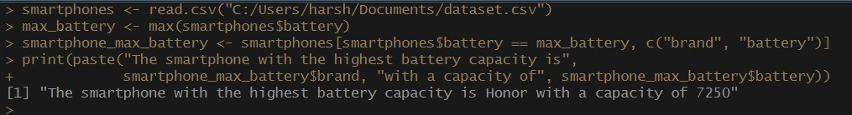

Q 2) What is the average screen size (in inches) of the smartphones in this dataset?

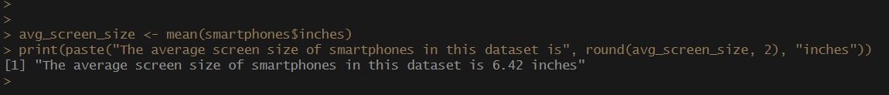

Q 3) Among the Android 7.0 operating system smartphones, which one has the highest resolution?



Q 4) What is the price range (in USD) for smartphones with 1080x1920 resolution and Android 7.0 operating system in this dataset?

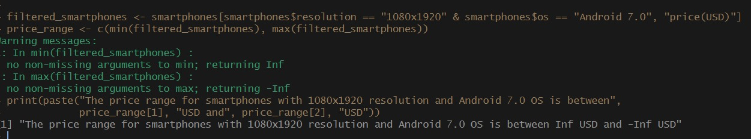

Q 5) What is the average weight (in grams) of smartphones announced in 2017?

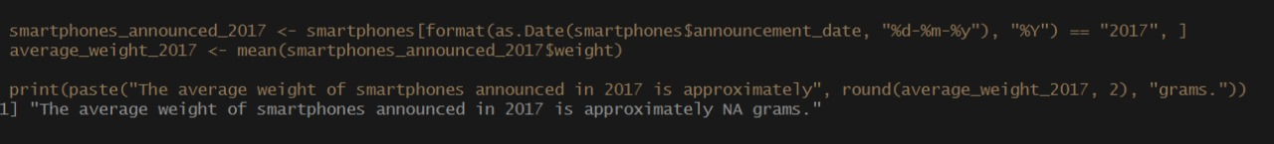

Q 6) What is the average battery capacity (in mAh) of smartphones with 1080p resolution and 4GB of RAM?

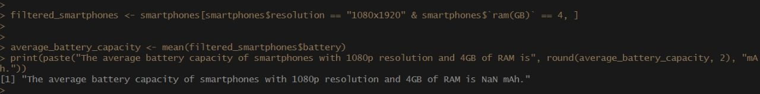

Q 7) Among smartphones with Android 7.0, what is the median weight (in grams)?

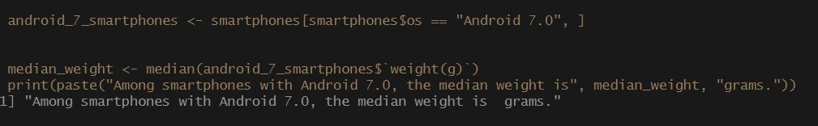

Q 8) How many smartphones in the dataset support 8K video recording and have a battery capacity greater than 4000 mAh?

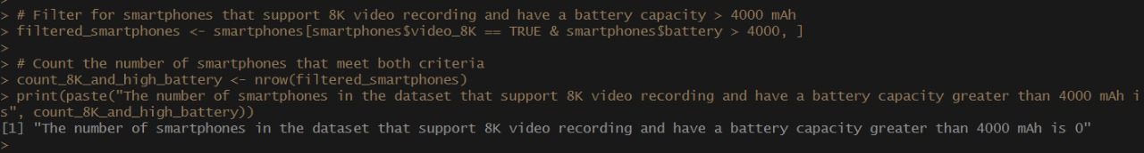

Q 9) What is the earliest announcement date in the dataset, and which smartphone was announced on that date?

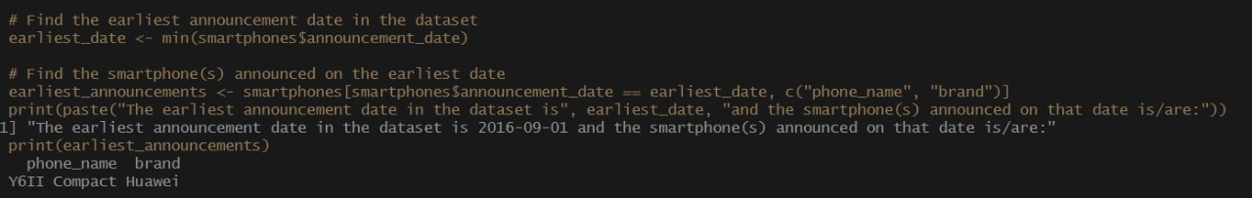

Q 10) Among smartphones with at least 32GB of storage, what is the average weight (in grams) for Sony brand smartphones?



Statistical Analysis

Q) Mean

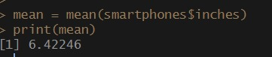

Q) Median

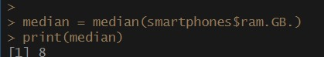

Graphs

